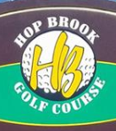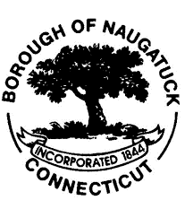

Hop Brook Players Club
  - 2026

  - 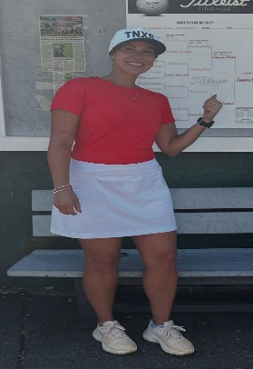 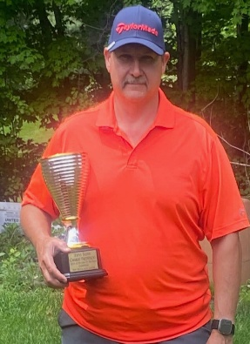 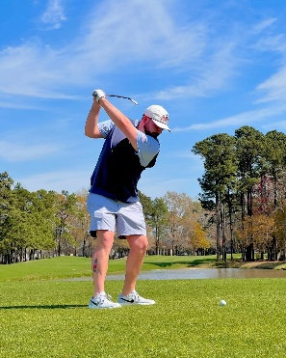 2025 Women’s Champion 2025 Hop brook POY 2025 Men’s champion shannon Bahme-Rodriguez Steve Slekis Mike Erickson

Tournament Schedule
Rules & Regulations

Date | Weekend Event | Format
April 24,25 | Stroke Play
April 26 | Opening Event
May 1-3 | Select Partners
May 8-10 | Select 9
May 15-17 | Criers
May 21-24 | Quota
May 25 | Memorial Day 2-Person BB
May 29-31 | Stableford
June 5-7 | Stroke Play
June 12-14,14 | Odd/Even Holes | Sun. Father/Child
June 19-21 | Pick your Partner
June 26-28 | Match Play vs. Par
July 3 | HBPC Firecracker Open
July 4,5 | Select 9
July 10-12 | Blind Partners
July 17-19 | Stroke Play Member/Member
July 24-26 | 3’s,4’s,5’s
July 31-Aug 2 | Quota
August 7-9 | Match Play vs. Par
August 14-16 | Criers | Junior Championship
August 22,23 | Hop Brook Champ 1st 2nd Rounds
August 29,30 | Hop Brook Champs Semi/Finals
September 5-7 | 3’s.4’s,5’s
September 7 | Blind Partners
September 11-13 | Stroke Play | Men’s & Women’s Seniors
Sept. 18-20,20 | Blind 9
Sept 27 | CLOSING EVENT Mem/Guest
 | NON HBPC EVENTS
Oct 11 | HOP BROOK SHOOTOUT
Oct 18 | HOP BROOK X-COUNTRY
Oct 25 | HOP BROOK Mayor’s 1-Club
Nov 7,8 | HOP BROOK 2026 Ryder Cup
Nov 30 | HOP BROOK HANGOVER CLASSIC
2026 Tournament Schedule

Hop Brook Players Club Member Handbook
Table of Contents

General Policies………………………………………… 1
Purpose
Membership
Player Conduct
Tee Times
Tournament Policies…………………………………... 2-3
Tournament Rules
Weekend Sign-Up
Major Events
Re Entries
Scorecards
Scoring………………………………………………… 3-4
Tees / Tournament Descriptions
Inclement Weather
Posting Scores

General Policies
Purpose: Hop Brook Players Club was formed exclusively for the purpose to encourage, foster, promote playing golf and participation in all golf related social activities. We aim to enhance interaction and fellowship among its members.
Membership: An active member in good standing is at least 18 years old and has paid the annual membership dues. There are two types of memberships offered.
Full Member $60
Unlimited access to all weekly tournaments and 3 Majors
USGA Handicap
Preferred Tee times 9 days in advance
Access to all social events & Club championship
Associate Member $50
USGA Handicap
Preferred tee times 7 days in advance
Access to all social events & Club Championship
Access to Member/Member & Member/Guest
Player Conduct: Hop Brook Players Club members shall conduct themselves in a responsible manner at all times. Any excessive lack of golfing etiquette or disrespect to a fellow player, golf course staff member, or any other individual maybe grounds for disqualification from any event and expulsion from the Players club. All members are required to report any infractions of the above or the Rules of Golf by any member that may be cause for disqualification from the event or the Players Club.
Tee Times: Full members may make Tee-times 9 days in advance with the intention of participating in that weekends event.
Tournament Policies
Tournament Rules: Hop Brook Players Club members shall observe all USGA, local and tournament rules including scoring, submitting scores and following the handicap system.

Tournament Play and Scoring: Weekly event scorecards must be signed by the participant and attested by another individual. All scorecards must be deposited in the drop box in the golf shop.

Ruling Questions: If there is a question regarding a golf ruling, please play two balls pursuant to USGA Rule 20.1© (Note: This is applicable to stroke play events only) A decision will be made by the golf shop.

Weekly Sign Up: A sign-up sheet for the weekly events will be located in the pro-shop. Weekly Events are a $5 entry fee. After signing up each player must place their name on the scoresheet located in front of the golf shop. Any player not signing up before teeing off the 1st hole will not be eligible.

Re-Entry: Any member who wishes to re-enter a weekly event can do so by paying a $7 re-entry fee. By re-entering your previous score is automatically eliminated.

Scoring
Tees: Players are allowed to play the tees of their choice, however they must be clearly marked on the scoresheet located in the front of the golf shop.
Posting Scores: The handicap committee will post scores for ALL HBPC events. Members are responsible to post their own scores in the following:
- Post scores from home and away played outside HBPC events.
- Post all scores from all forms of play
- Post your score when you play at least 13 of 18 holes or at least 7 of 9 holes. On holes you didn’t play, record a par plus and handicap strokes you would receive.
- Post all 9 hole scores from any league play.
- Post scores played in an area observing an active season even when your home club is in an inactive season.
Failure by a member to post scores in the situations above can result in the players’ handicap being reduced for HBPC events.

Members should not post a score in these situations:
- If you play fewer than 7 holes.
- When you play an event limiting clubs i.e. (1-club, irons only)
- Any 18-hole course less than 3,000 yards
- When a majority of the holes aren’t played under the Rules of Golf
- Do not post a score in an area observing an inactive season.
ESC_- Equitable Stroke Control: For handicap purposes, after your round you are required to adjust your hole scores when they are higher than your maximum ESC. All scores, including tournament scores, are adjusted.

Tournament Descriptions
STROKE PLAY:
18 Holes individual gross and net event. Play tees of your choice. 100% handicap allotment.
SELECT PARTNERS:
At completion of play, partners are drawn by the tournament committee. 100% handicap with team gross and team net prizes.
CRIERS:
18 holes’ stroke play with 100% handicap. Change your 2 worst holes to par then deduct handicap for net score.
BLIND 9:
Play 18 holes. At completion of play 9 holes are randomly selected by the tournament committee. 50% handicap gives you your 9-hole net score.
QUOTA:
This is an individual point event. Deduct your handicap from 35 which gives you your “Quota” for the event. Earn points each hole as follows
Double Bogie and up: 0 points Eagle: 8 points
Bogey: 1 point Albatross: 16 points
Par: 2 points Hole-in-one: 32 points
Birdie: 4 points
ODD/EVEN HOLES:
18 holes individual. After completion of play tournament committee will pull odd number holes on front and even holes on back, or vice versa. 50% handicap gives you your 9-hole net score.

2 MAN COMBINED:
Select your own partner. 18 holes with 100% handicap. Gross and net prizes.
STABLEFORD:
Individual point event based on point system with 100% handicap. Highest point total wins. Points are awarded for net score per hole as follows:
Double bogie and up: 0 points
Bogey: 1 point
Par: 2 points
Birdie: 3 points
Eagle: 4 points
Albatross: 5 points

3,4,5s
18 Holes with 50% handicap using your best score on (2) Par 3’s, (2) par 5’s and (5) Par 4’s. Best 9 hole score wins.

6-6-6
18 holes with 50% handicap using your worst 3 holes of your 1st, 2nd, and last 6- holes of your round. Best 9 hole score wins.

2026 Hop Brook Championships

2026 CHAMPIONSHIPS: Qualifying for the 2025 Hop Brook Championship runs during the month of July and August, 18 holes. $10 entry fee. Men’s and Women’s divisions broken into flights determined by qualifying score. 1st and 2nd round matches are scheduled for August 23rd and 24th, with Semi and Finals scheduled for August 30th and 31st.

2026 MEN’S & WOMEN’S SENIOR CHAMPIONSHIPS: Senior Championship are held in September. $5 entry fee. There are both gross and handicap flights available.

2026 SUPER SENIORS: Open to all senior players ages 70 and over. $5 entry, held in the month of September. 9 hole matches with handicaps played from the gold tees.

2026 JUNIOR CHAMPIONSHIPS: The 2025 Junior championship will be held in August. Separate age divisions for both boys and girls. $5 entry, 9-hole event.

Again for 2026 “Player of the Year”

Returning for the 2026 season was the HBPC “Player of the Year”. This award will be determined by a points based system throughout the season. Players will earn points via weekly events, major events, and the Hop Brook Championship. The player with the most points will be crowned “Player of the Year” and receive a 2027 Hop Brook membership, and an automatic selection to the 2026 Ryder Cup team. The next 3 players in the overall points category will also receive Ryder Cup invitations as well. Points can be earned as follows:

Weekly Events Major Events
1st Place- 15 pts 1st Place- 50 pts
2nd Place- 10 pts 2nd Place- 35 pts
3rd Place- 7 pts 3rd Place- 25 pts
4th Place- 5 pts 4th Place- 20 pts
5th Place- 3 pts 5th Place- 15 pts

HB Championship Flight HB Senior Champions
Flight Champ- 75 pts Flight Champ- 25 pts
Runner-up- 50 pts Runner-up- 20 pts
Semi-Finalist- 40 pts Semi-finalist- 15 pts
Quarters- 30 pts. Quarters- 10 pts
Qualifier- 20 pts

HB Champ 1st Flight HB Champ 2nd Flight
Flight Champ – 35 pts Flight Champ – 30 pts
Runner-up - 25 pts Runner up – 20 pts
Semi- Finalist - 15pts Semi Finalist - 12 pts
Quarters - 10 pts Quarters - 8 pts

HB Champ 3rd Flight HB Champ 4th Flight
Flight Champ – 25 pts Flight Champ – 20 pts
Runner-up - 15 pts Runner-up - 10pts
Semi-Finalist – 10 pts Semi-Finalist – 8 pts
Quarters - 7 pts Quarters - 5pts

2025 Hop Brook Player of the Year Standings

Steve Slekis – 235

Steph Slekis- - 172

Pete Gallino - 105

Dan Kudej - 105

Dale Sweet – 101

Jim Robinson – 91

Bill Testone -87

Shannon Bahme – 85

Sam Molnar – 84

Joe Edmonds – 82

Pat Granahan - 80

Mark Trisko - 75

Mike Erickson – 75

Dave Ranno – 72

Hannah Hallissey - 70

Tye Rogers – 69

Charlie Fredericks – 66

Tracy Litke - 65

Ron Swierbitowicz – 64

Paul Padilla – 64

Jim Russo - 62

Ryan Murphy – 53

Jason Rizk – 53

Fuoad Rizk – 53

George Lockwood - 50

Gino Ferrucci – 48

A.Lopez-Woodworth- 45

Lianne Wallace – 45

Tracy Litke – 45

Terry Pemberton – 45

Kerrin Kallmann – 45

Glen Petelle - 45

Vic Chernesky - 36

Henry Ruiz – 35

Mark Case - 33

Gregory Bush – 30

Lenny Santaserio – 30

Vin Ferrucci – 30

Maryann Branco - 30

Jerry Molnar – 27

Carol Douty – 25

Mike Breen - 25

Lorianne Adamaitis – 25

Dan Testone – 25

Sydney Hunt – 25

Nick Tribanas – 25

Joe Pascucci – 25

Manny Tribanas - 25

Craig Linda – 23

Larry Testone – 22

Chuck Czajkowski – 22

Bob Swierbitowicz – 22

Pete Hess - 20

Lou Ferrucci – 20

Kim Gallo – 20

Nancy Barton – 20

Kristan Crosswait – 20

Past Player of the Year Champions
2022 Jim Robinson
2023 Steve Slekis
2024 Charlie Fredericks & Steve Slekis(Co-Champions)
2025 Steve Slekis

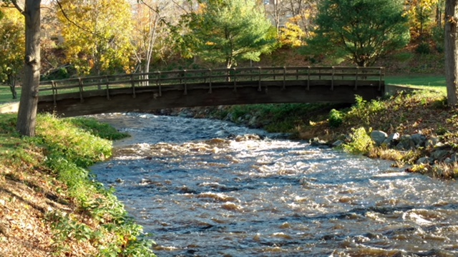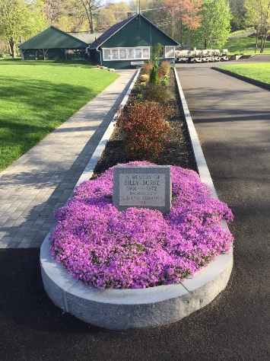

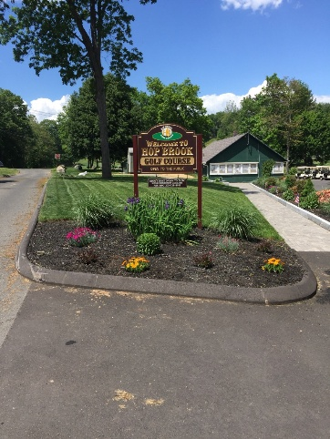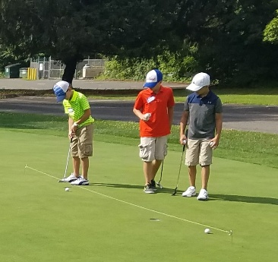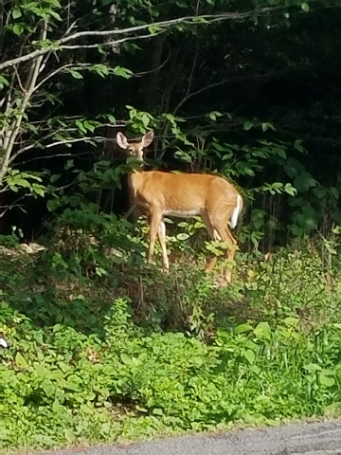



If you have questions, comments or would like to volunteer on a committee for the Hop Brook Players Club please reach out to
bnixon@pga.com.

